Crossed Polygon
# Source: AI Source: Provided by: [Data Path: Persons Table -> ID Column: 1, Name_En Column: Motasem Essam] -> From: [ChatGPT] on [7/25/2026]
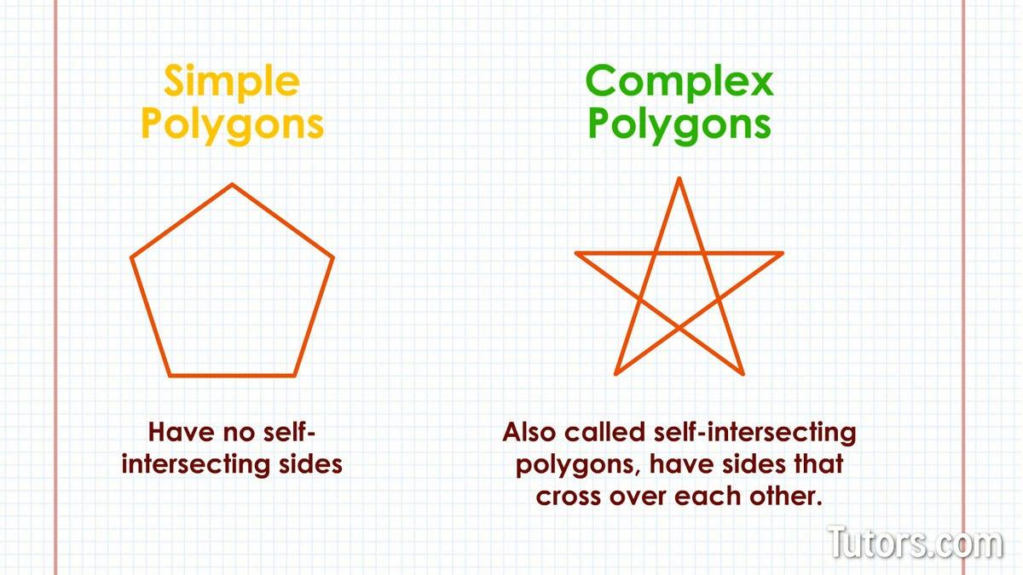
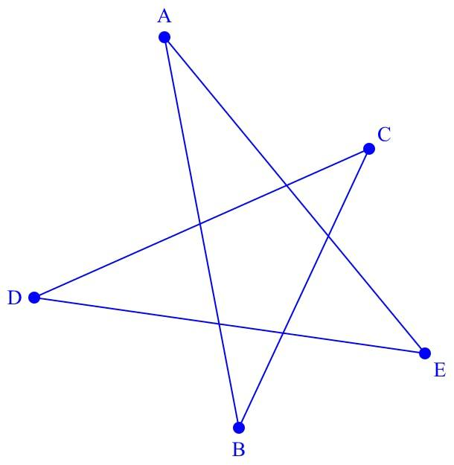
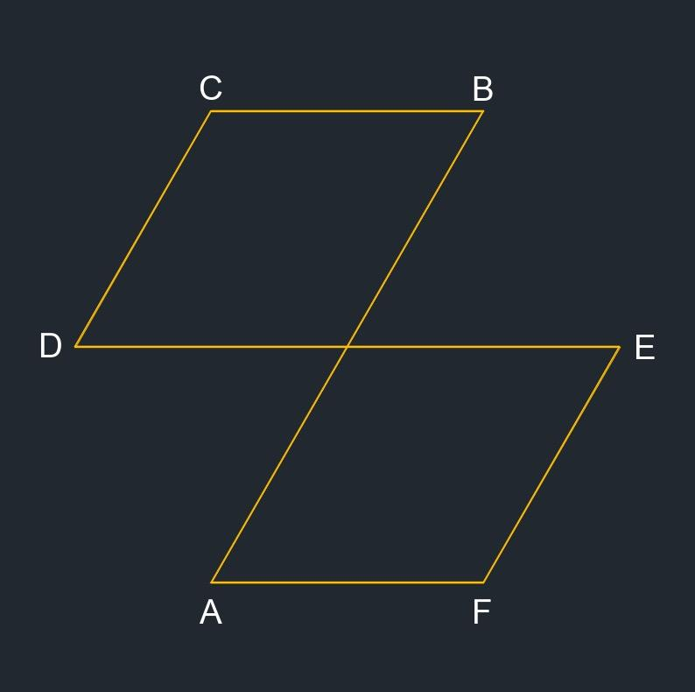
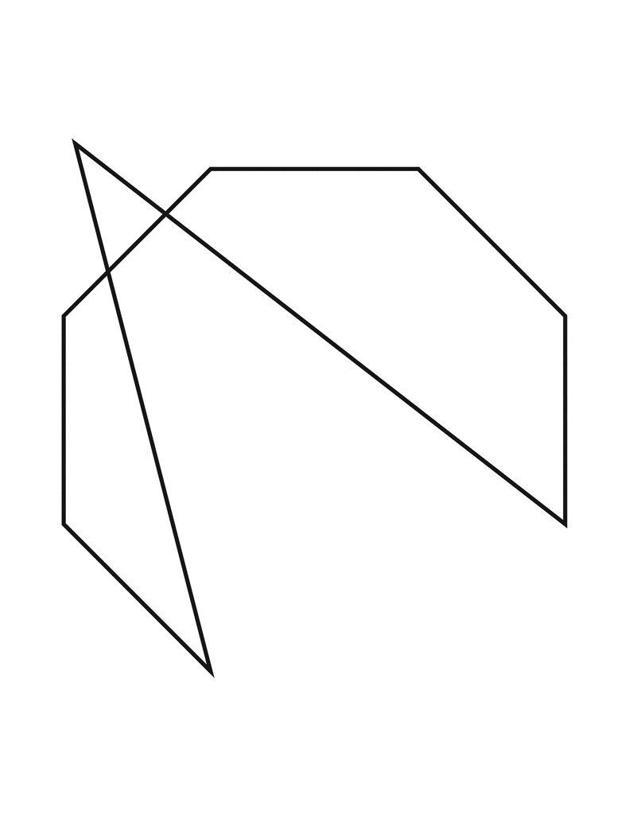
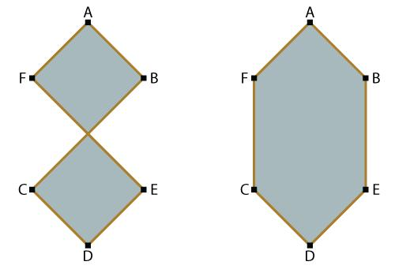

Definition
# Source: AI Source: Provided by: [Data Path: Persons Table -> ID Column: 1, Name_En Column: Motasem Essam] -> From: [ChatGPT] on [7/25/2026]
A Crossed Polygon is a polygon whose boundary sides (edges) intersect each other at one or more points other than their common endpoints.
It is therefore a self-intersecting polygon.
$$\boxed{\text{Crossed Polygon}=\text{Self-Intersecting Polygon}}$$
A crossed polygon is also commonly called a complex polygon.

Fundamental Elements
# Source: AI Source: Provided by: [Data Path: Persons Table -> ID Column: 1, Name_En Column: Motasem Essam] -> From: [ChatGPT] on [7/25/2026]
A crossed polygon consists of:
- 3 or more vertices
- 3 or more edges
- A closed sequence of line segments
- One or more self-intersection points
- Multiple regions may be formed by the crossings
For vertices
$$A_{1},A_{2},…,A_{n}$$
the edges are:
$$A_{1}A_{2}, A_{2}A_{3},…,A_{n}A_{1}$$
If two non-adjacent edges intersect, the polygon is crossed.

Defining Property
# Source: AI Source: Provided by: [Data Path: Persons Table -> ID Column: 1, Name_En Column: Motasem Essam] -> From: [ChatGPT] on [7/25/2026]
For a simple polygon:
$$\boxed{\text{Non-adjacent edges do not intersect}}$$
For a crossed polygon:
$$\boxed{\text{At least two non-adjacent edges intersect}}$$
The intersection must occur at a point that is not a common endpoint.

Example
# Source: AI Source: Provided by: [Data Path: Persons Table -> ID Column: 1, Name_En Column: Motasem Essam] -> From: [ChatGPT] on [7/25/2026]
Consider a polygon with vertices:
$$A, B, C, D$$
connected in the order:
$$A→B→C→D→A$$
If:
$$AB∩CD=O$$
where $O$is not a vertex, then the polygon is self-intersecting.
For four vertices, this produces a Crossed Quadrilateral.
$$\boxed{\text{Crossed Quadrilateral}⊂\text{Crossed Polygon}}$$

Types of Crossed Polygons
# Source: AI Source: Provided by: [Data Path: Persons Table -> ID Column: 1, Name_En Column: Motasem Essam] -> From: [ChatGPT] on [7/25/2026]
Crossed polygons can have different numbers of sides.
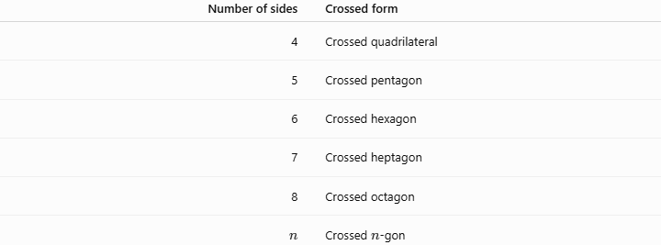
Number of sides | Crossed form
4 | Crossed quadrilateral
5 | Crossed pentagon
6 | Crossed hexagon
7 | Crossed heptagon
8 | Crossed octagon
$$n$$ | Crossed $n$-gon
The important characteristic is not the number of sides but the self-intersection.

Simple Polygon vs. Crossed Polygon
# Source: AI Source: Provided by: [Data Path: Persons Table -> ID Column: 1, Name_En Column: Motasem Essam] -> From: [ChatGPT] on [7/25/2026]
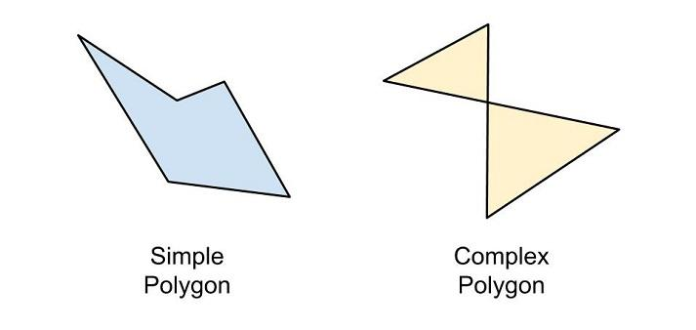
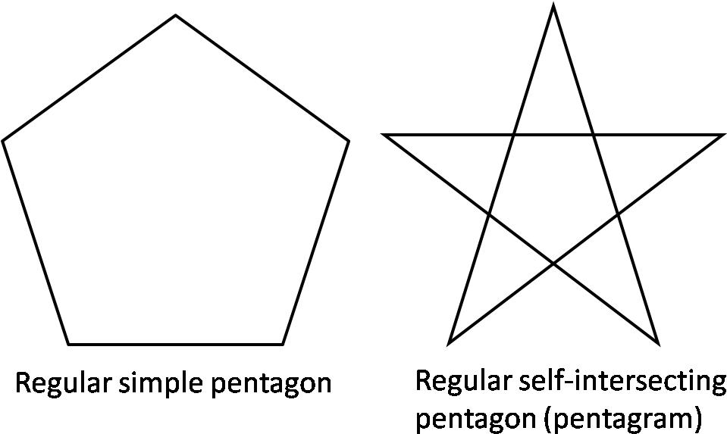
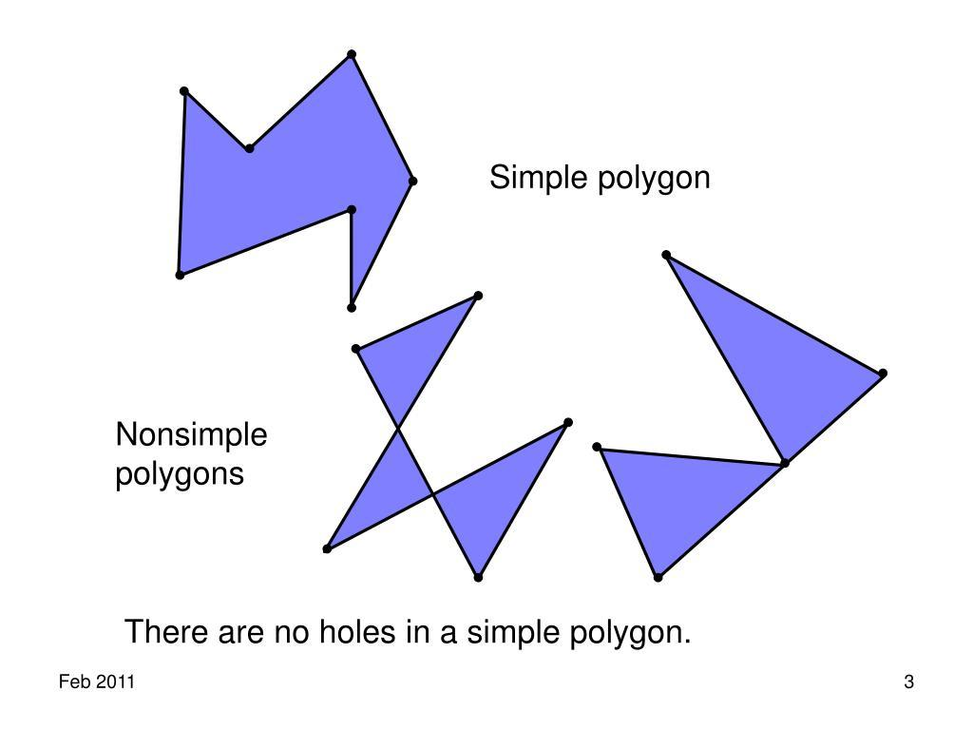
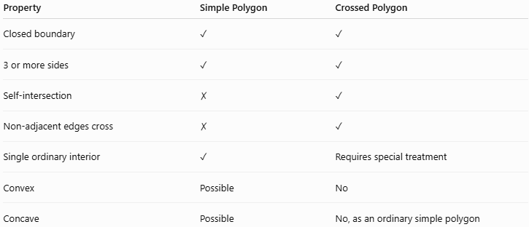
Property | Simple Polygon | Crossed Polygon
Closed boundary | ✓ | ✓
3 or more sides | ✓ | ✓
Self-intersection | ✗ | ✓
Non-adjacent edges cross | ✗ | ✓
Single ordinary interior | ✓ | Requires special treatment
Convex | Possible | No
Concave | Possible | No, as an ordinary simple polygon

Convex, Concave, and Crossed
# Source: AI Source: Provided by: [Data Path: Persons Table -> ID Column: 1, Name_En Column: Motasem Essam] -> From: [ChatGPT] on [7/25/2026]
These are important structural categories:
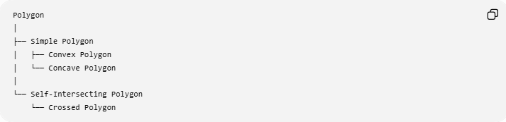
Polygon
│
├── Simple Polygon
│ ├── Convex Polygon
│ └── Concave Polygon
│
└── Self-Intersecting Polygon
└── Crossed Polygon
Therefore:
$$\boxed{\text{Convex}≠\text{Concave}≠\text{Crossed}}$$
A convex polygon and a concave polygon are both simple polygons.
A crossed polygon is self-intersecting.

Self-Intersection Points
# Source: AI Source: Provided by: [Data Path: Persons Table -> ID Column: 1, Name_En Column: Motasem Essam] -> From: [ChatGPT] on [7/25/2026]
A crossed polygon may have one or several crossing points.
If two edges intersect at $O$:
$$\boxed{A_{i}A_{i+1}∩A_{j}A_{j+1}=O}$$
then $O$is a self-intersection point.
At such a point, the ordinary properties of intersecting lines apply.
For example, vertical angles are equal:
$$\boxed{∠1=∠3}$$
and:
$$\boxed{∠2=∠4}$$

Perimeter
# Source: AI Source: Provided by: [Data Path: Persons Table -> ID Column: 1, Name_En Column: Motasem Essam] -> From: [ChatGPT] on [7/25/2026]
The perimeter is the sum of the lengths of all boundary edges:
$$\boxed{P=s_{1}+s_{2}+⋯+s_{n}}$$
For a crossed pentagon:
$$P=AB+BC+CD+DE+EA$$
The crossing points do not become additional sides.

Area
# Source: AI Source: Provided by: [Data Path: Persons Table -> ID Column: 1, Name_En Column: Motasem Essam] -> From: [ChatGPT] on [7/25/2026]
Area is more complicated than for a simple polygon because the boundary can create several regions.
There are two important approaches.
1. Geometric Area
If the problem asks for the actual areas of the enclosed regions, calculate the relevant regions separately.
For example:
$$\boxed{A=A_{1}+A_{2}+A_{3}}$$
depending on the particular shape.
2. Signed Area
In advanced mathematics and computational geometry, a crossed polygon can be assigned a signed area.
Some regions may contribute positively and others negatively depending on the direction in which the boundary is traversed.
Therefore:
$$\boxed{\text{Area of a crossed polygon requires a specified convention}}$$
The ordinary simple-polygon area interpretation should not automatically be assumed.

Interior Angles
# Source: AI Source: Provided by: [Data Path: Persons Table -> ID Column: 1, Name_En Column: Motasem Essam] -> From: [ChatGPT] on [7/25/2026]
For a simple $n$-gon, the interior-angle sum is:
$$\boxed{S=\left(n-2\right){180}^{∘}}$$
However, this formula should not be directly applied to a crossed polygon as though it were a simple polygon.
The self-intersection changes how the interior regions and angles are defined.
This is one of the important differences between:
$$\text{Simple Polygon}$$
and
$$\text{Crossed Polygon}.$$

Example: Crossed Quadrilateral
# Source: AI Source: Provided by: [Data Path: Persons Table -> ID Column: 1, Name_En Column: Motasem Essam] -> From: [ChatGPT] on [7/25/2026]
Take:
$$A\left(0 , 0\right), B\left(4 , 4\right), C\left(0 , 4\right), D\left(4 , 0\right)$$
and connect:
$$A→B→C→D→A$$
The edges cross at:
$$O=\left(2 , 2\right)$$
Thus:
$$AB∩CD=O$$
and the polygon is a:
$$\boxed{\text{Crossed Quadrilateral}}$$
which is a particular type of crossed polygon.

Star Polygons
# Source: AI Source: Provided by: [Data Path: Persons Table -> ID Column: 1, Name_En Column: Motasem Essam] -> From: [ChatGPT] on [7/25/2026]
Some star polygons are self-intersecting polygons.
For example, a pentagram is formed by connecting the vertices of a regular pentagon in a particular non-consecutive order.
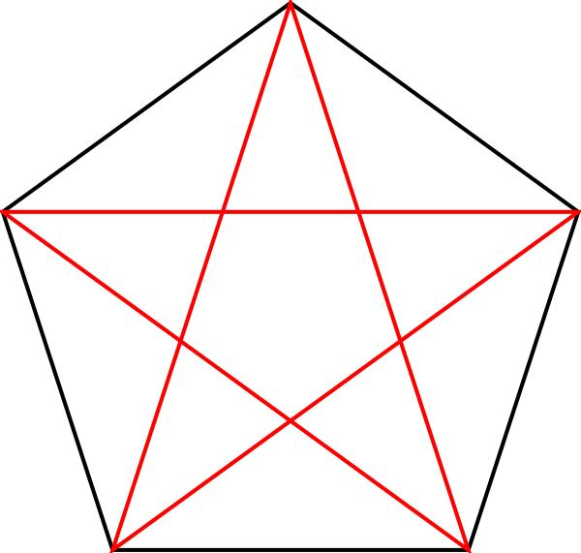
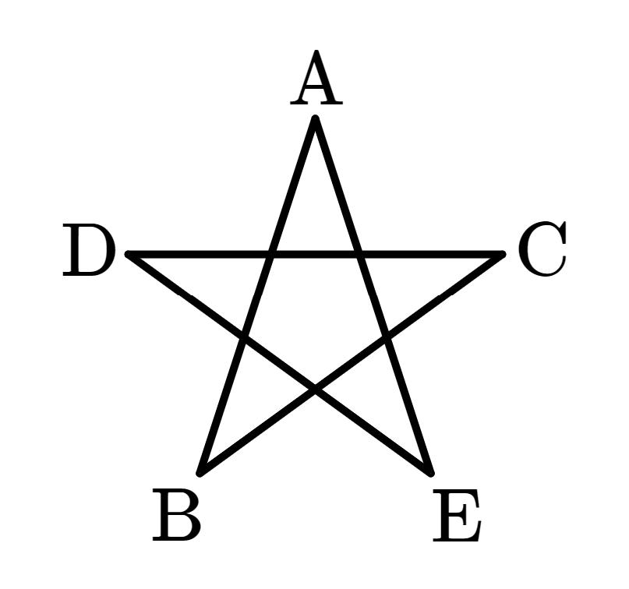
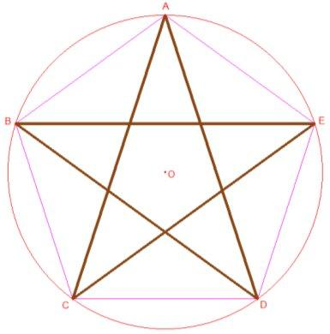
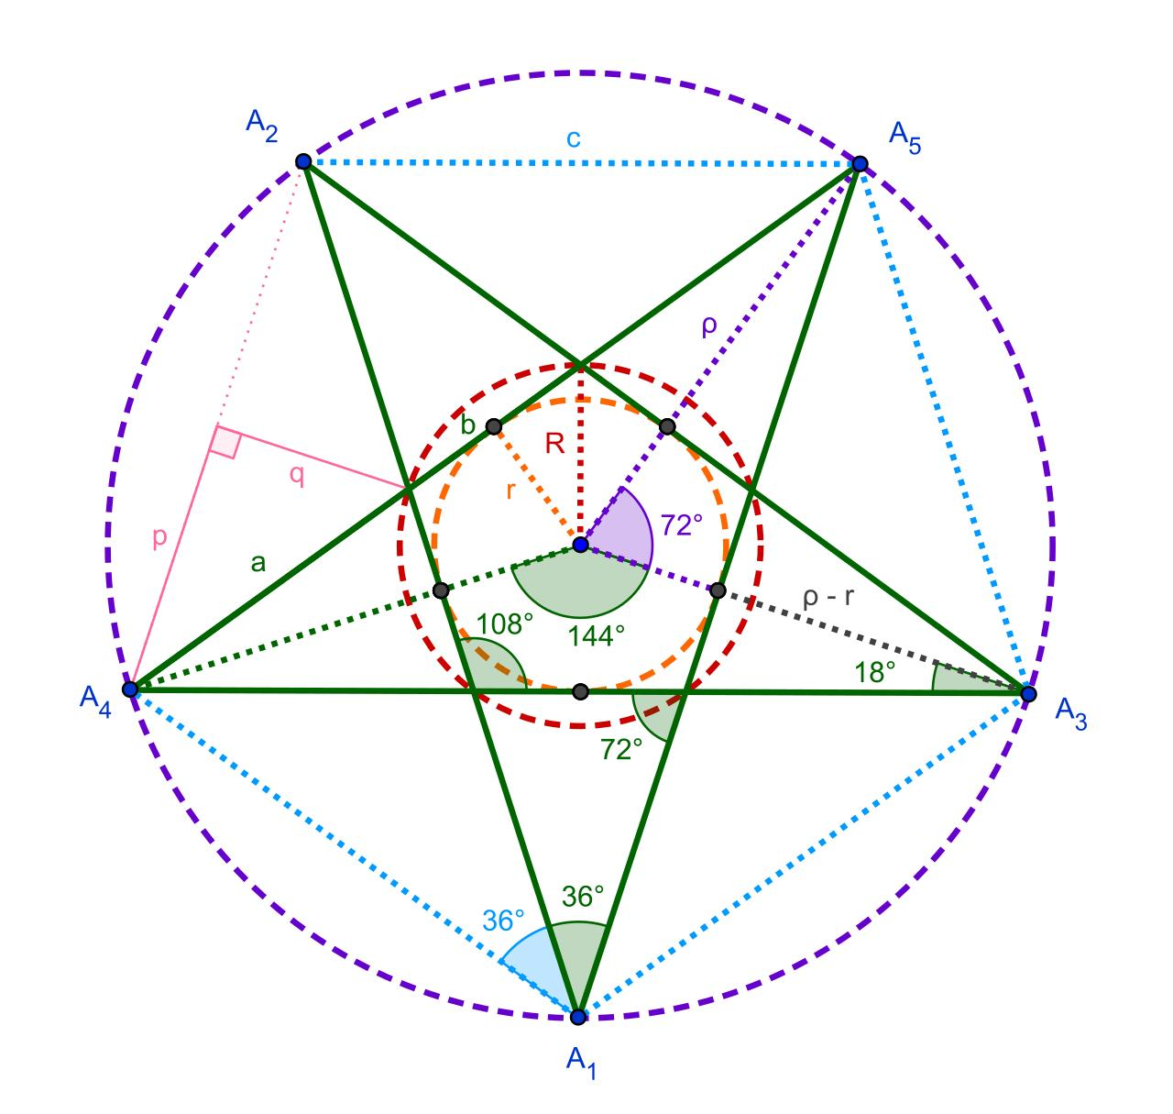
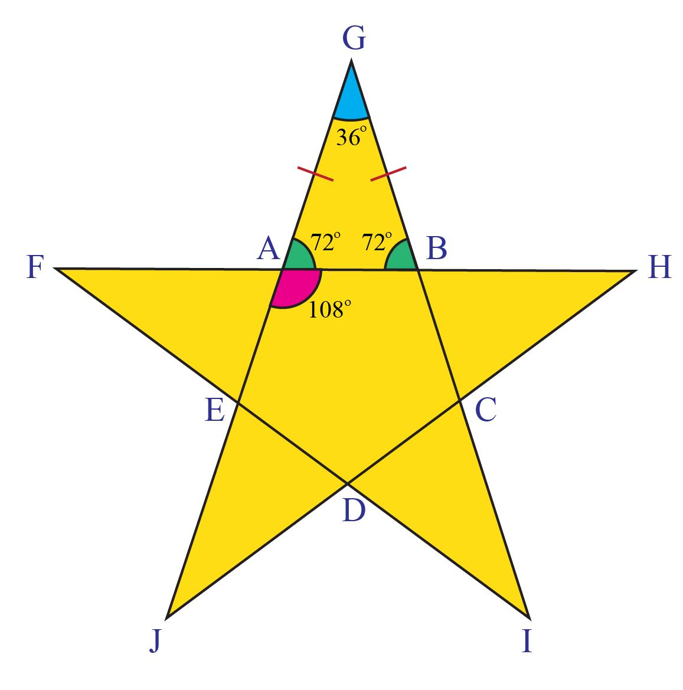
For a regular $n$-gon, changing the order in which vertices are connected can produce a self-intersecting star polygon.
Thus, star polygons provide important examples of crossed polygons.

Relationship with Crossed Quadrilateral
# Source: AI Source: Provided by: [Data Path: Persons Table -> ID Column: 1, Name_En Column: Motasem Essam] -> From: [ChatGPT] on [7/25/2026]
A crossed quadrilateral is simply the four-sided case:
$$\boxed{\text{Crossed Quadrilateral}=\text{Crossed 4-gon}}$$
Therefore:
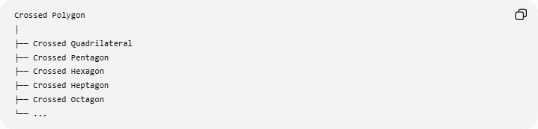
Crossed Polygon
│
├── Crossed Quadrilateral
├── Crossed Pentagon
├── Crossed Hexagon
├── Crossed Heptagon
├── Crossed Octagon
└── ...

Relationship with Crossed Shapes
# Source: AI Source: Provided by: [Data Path: Persons Table -> ID Column: 1, Name_En Column: Motasem Essam] -> From: [ChatGPT] on [7/25/2026]
The broader hierarchy can be organized as:
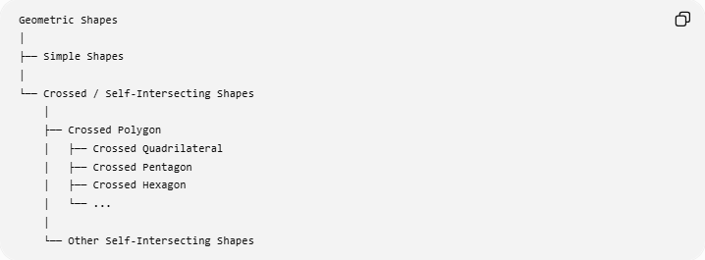
Geometric Shapes
│
├── Simple Shapes
│
└── Crossed / Self-Intersecting Shapes
│
├── Crossed Polygon
│ ├── Crossed Quadrilateral
│ ├── Crossed Pentagon
│ ├── Crossed Hexagon
│ └── ...
│
└── Other Self-Intersecting Shapes
For your knowledge base, I recommend using Self-Intersecting Polygon as the formal parent term and Crossed Polygon as the equivalent/common name.

Real-World Applications
# Source: AI Source: Provided by: [Data Path: Persons Table -> ID Column: 1, Name_En Column: Motasem Essam] -> From: [ChatGPT] on [7/25/2026]
Crossed polygons are encountered in:
- Computer graphics
- CAD
- Computational geometry
- Mathematical diagrams
- Star and decorative patterns
- Logo design
- Geographic information systems
- Shape modeling
- Animation
- Path and boundary algorithms

Advantages
# Source: AI Source: Provided by: [Data Path: Persons Table -> ID Column: 1, Name_En Column: Motasem Essam] -> From: [ChatGPT] on [7/25/2026]
- Useful for representing complex geometric paths.
- Important in computational geometry.
- Useful for studying intersections.
- Can create complex visual patterns.
- Useful for star polygons and decorative geometry.

Limitations
# Source: AI Source: Provided by: [Data Path: Persons Table -> ID Column: 1, Name_En Column: Motasem Essam] -> From: [ChatGPT] on [7/25/2026]
- Area calculations are more complicated.
- Interior regions may be ambiguous.
- Ordinary polygon formulas may require modification.
- Self-intersections can complicate computational geometry algorithms.
- The term crossed polygon describes the topology of the boundary rather than a specific shape.

Key Points
# Source: AI Source: Provided by: [Data Path: Persons Table -> ID Column: 1, Name_En Column: Motasem Essam] -> From: [ChatGPT] on [7/25/2026]
- A Crossed Polygon is a self-intersecting polygon.
- At least two non-adjacent edges cross.
- The crossing occurs away from the vertices.
- A crossed quadrilateral is the four-sided example.
- Some star polygons are crossed polygons.
- It is different from both convex and concave simple polygons.
- Perimeter is still the sum of all boundary-edge lengths.
- Area and interior angles require special treatment.

Conclusion
# Source: AI Source: Provided by: [Data Path: Persons Table -> ID Column: 1, Name_En Column: Motasem Essam] -> From: [ChatGPT] on [7/25/2026]
A Crossed Polygon is a polygon whose boundary intersects itself. It is the general polygonal category that contains figures such as crossed quadrilaterals and many star polygons.
The clean taxonomy for your knowledge base is:
$$\boxed{\text{Polygon}→\left\{\begin{matrix}\text{Simple Polygon} \\ \text{Self-Intersecting Polygon (Crossed Polygon)}\end{matrix}\right.}$$
and:
$$\boxed{\text{Crossed Quadrilateral}⊂\text{Crossed Polygon}}$$

